**BirdImage API DevOps Deployment**

Detailed solution provided throughout the code and necessary screenshots

* **Step 1 : Install and Run the App. (On Local through ubuntu system (using windows WSL utility))**

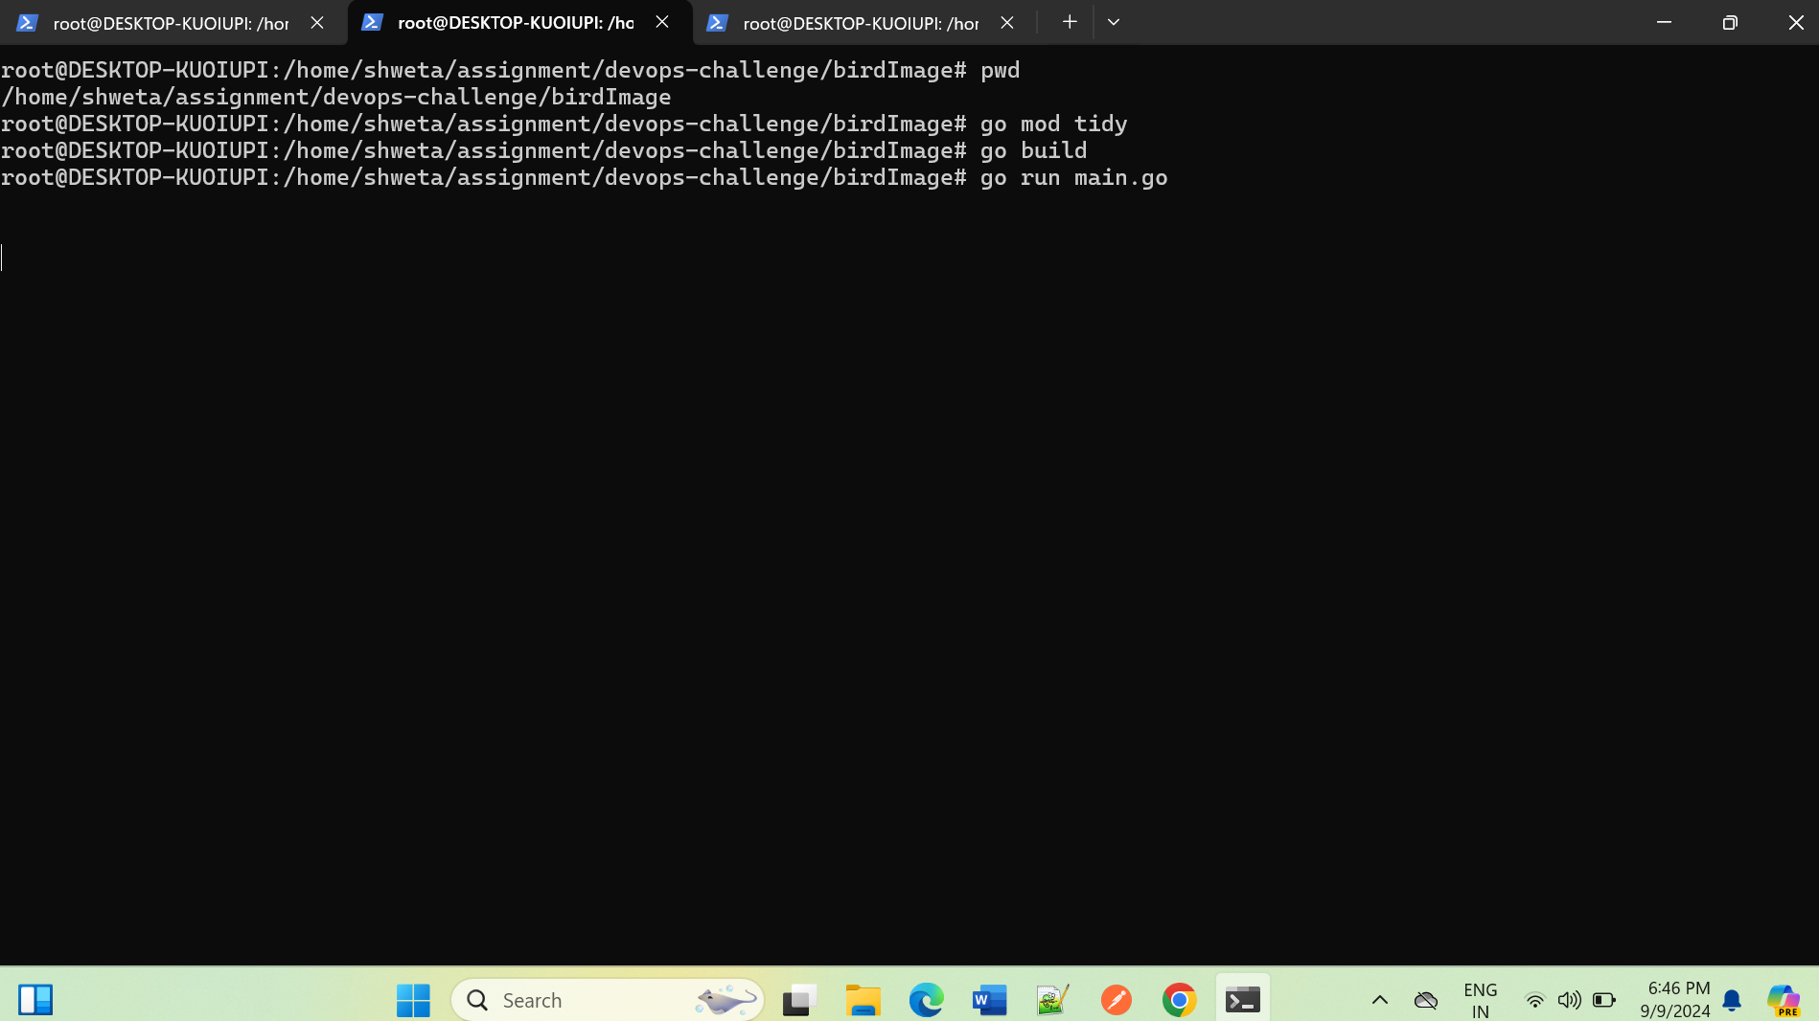

Ouput of API:

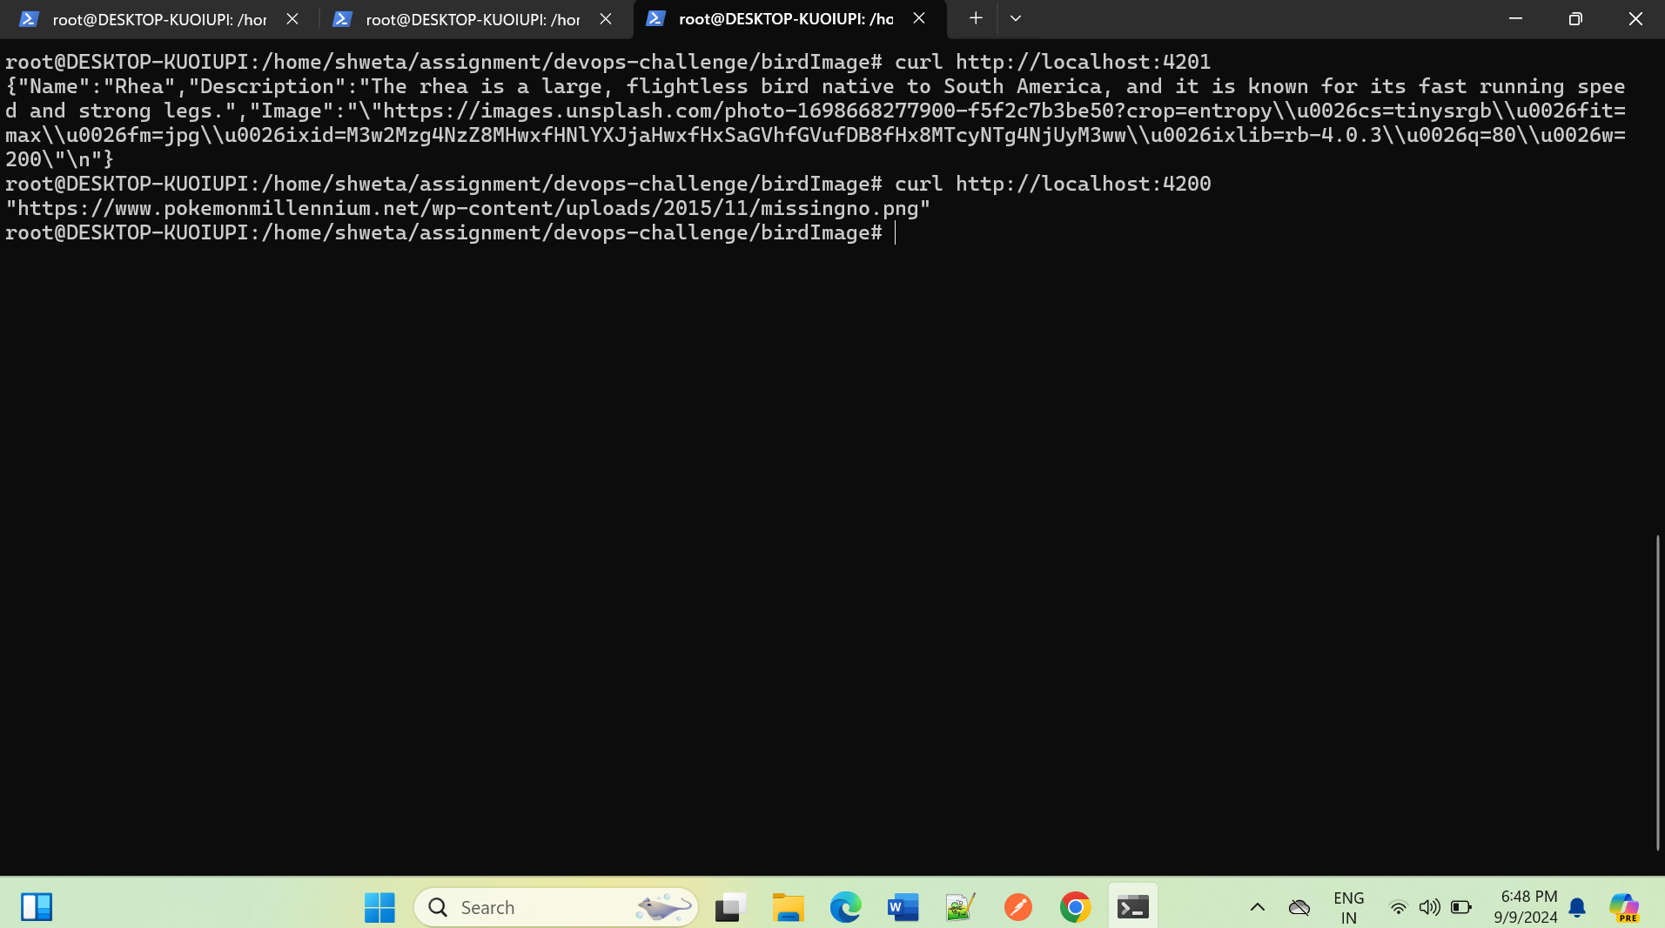

On browser:

url: http://localhost:4201

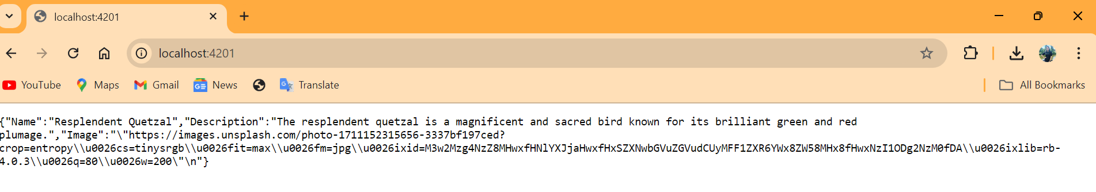

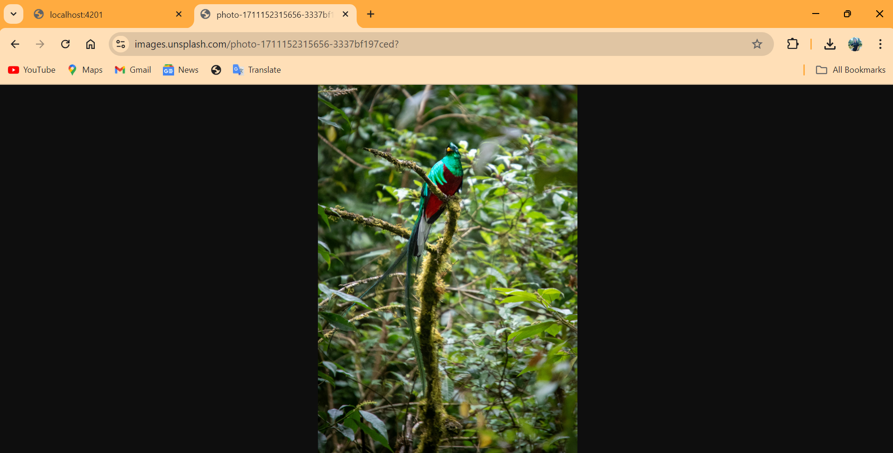

<http://localhost:4200> (BirdImage API)

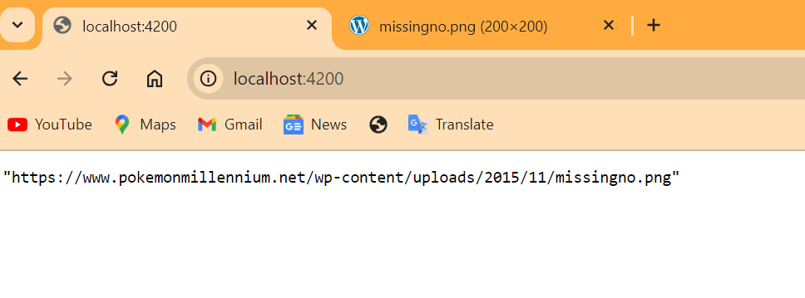

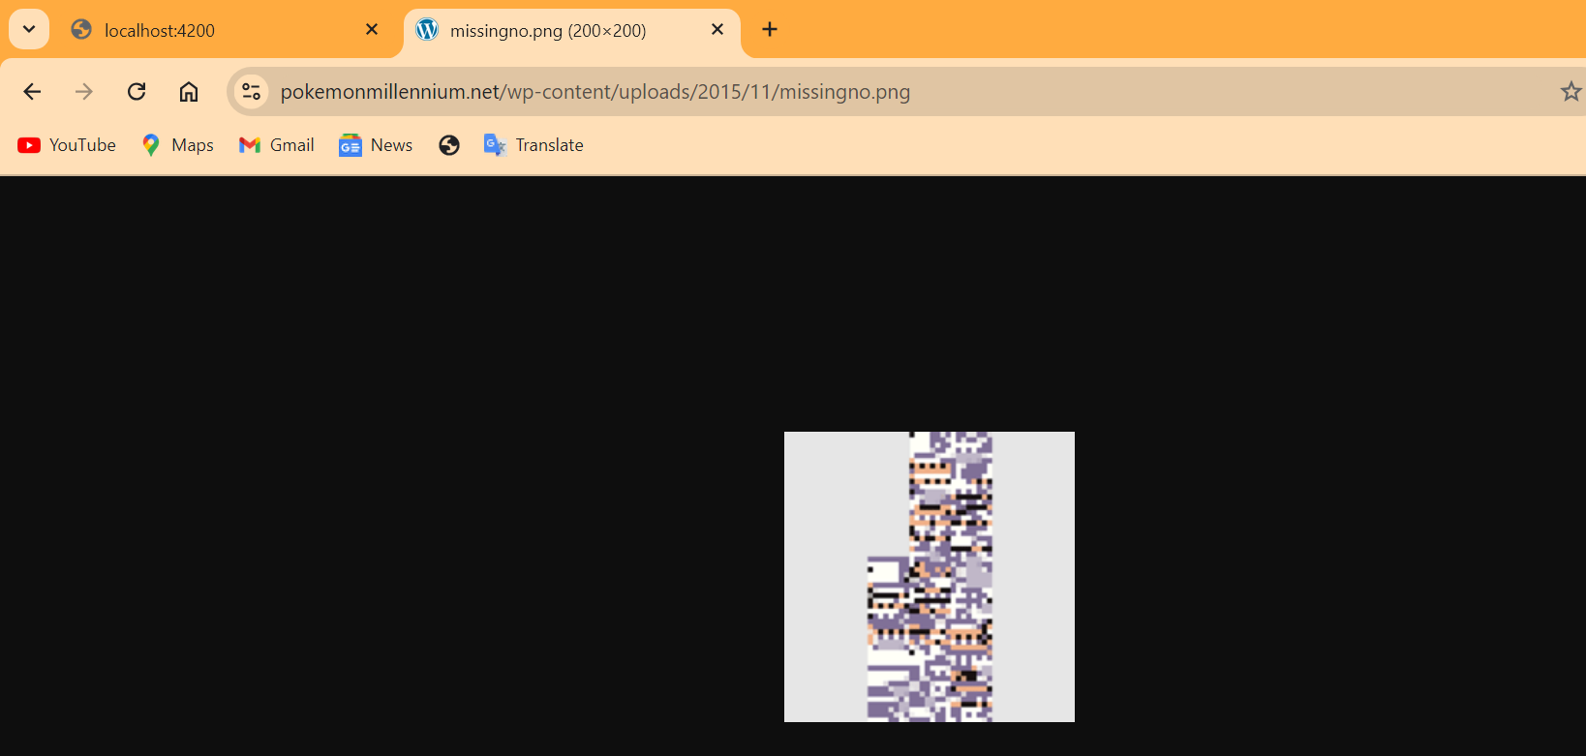

* **Step 2 : Dockerise it (create dockerfile for each API)**

Docker images:



Running API through Docker containers:

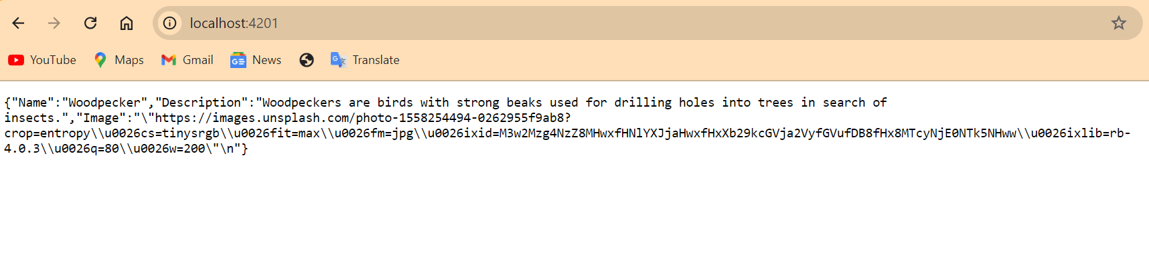

* **Step 3 : Creating infra AWS on IaC (Terraform):**

1. Key pair

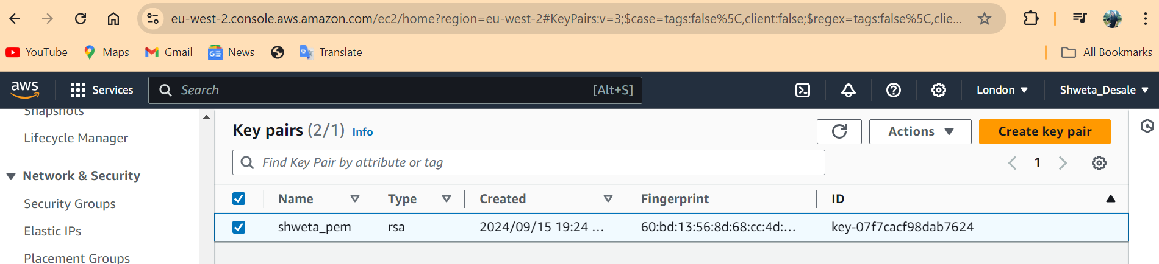

1. Security Group

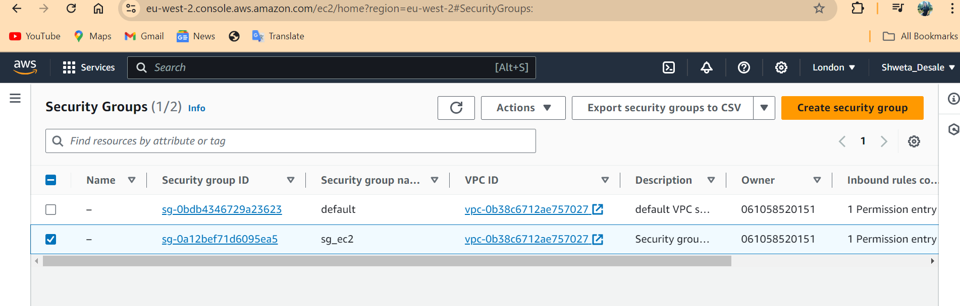

1. EC2 instance :

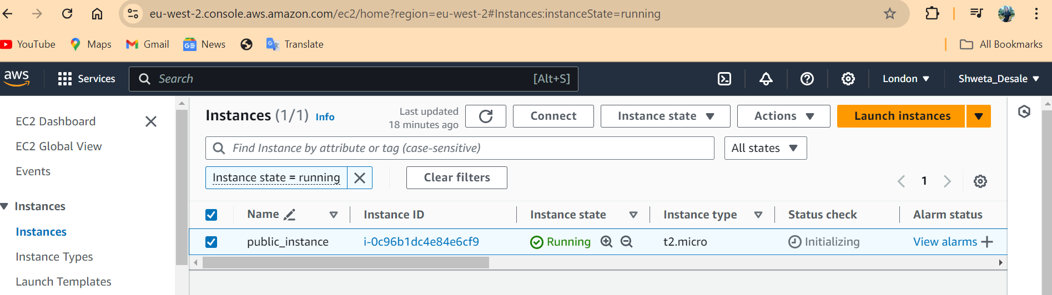

1. Accessing ec2 instance launched through terraform through SSH:

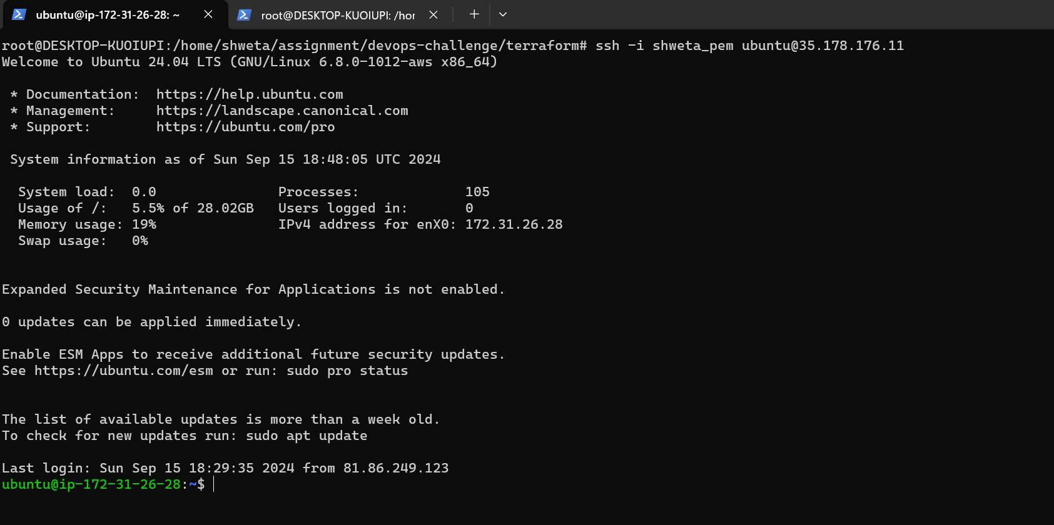

* **Step 4: Install a small version of Kubernetes on the instances (no EKS)**

1. Minikube is installed on t2.micro instance launch through IaC.

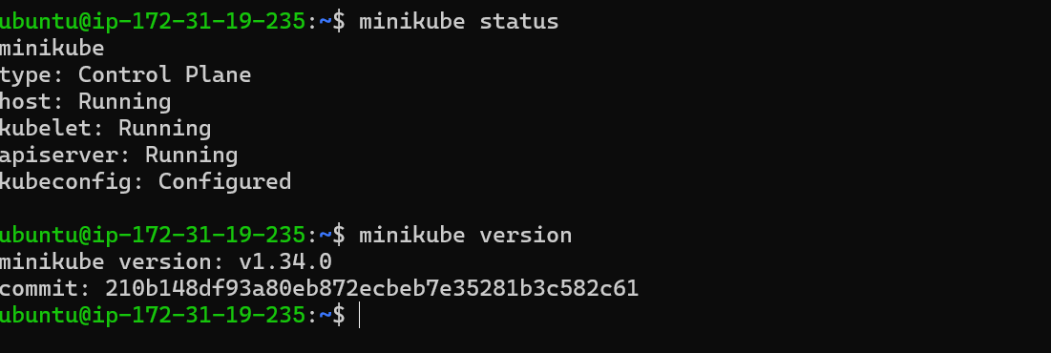

* **Step 5: Build the manifests to run the 2 APIs on k8s**

Deployment through kubernetes

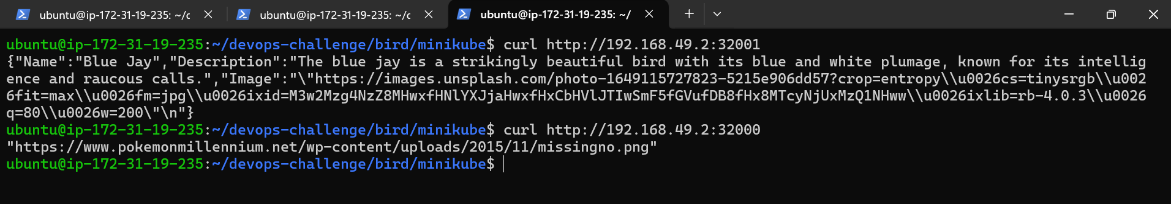

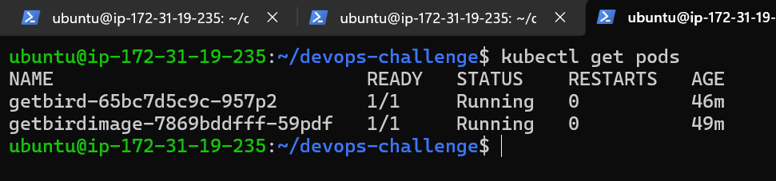

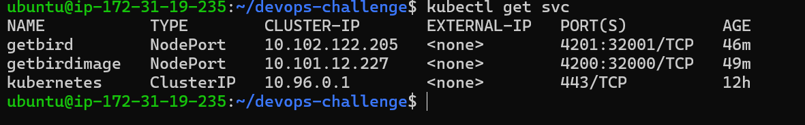

* **Step 6: Bonus points: observability, helm, scaling**
  1. Helm chart for getbird API:

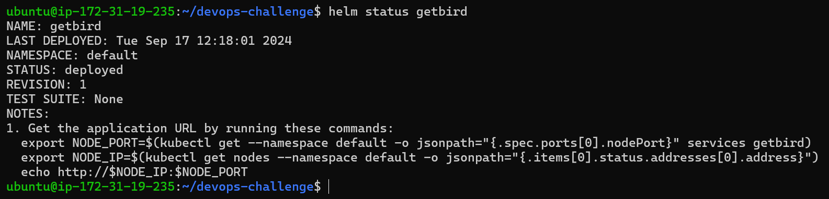

* 1. Autoscaling for 2 APIs (HPA):

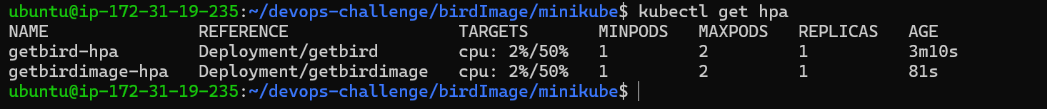

* 1. Limiting the resources in manifests:

